Chapter V
DISCUSSION OF RESULTS
In this chapter the results obtained after following the procedure reported in the previous chapter are to be discussed. not only the end results but also outcomes that led to some decisions to be taken and some generalizations. All results are to be analyzed along with the conclusion and the observation deduced is to be reported. The output might vary do the diversity of possible conditions, therefore the outputs expected to be affected differently are to be compared and this difference specifically will be an indicator for the desired information; the force magnitude and the force location of application. As it was mentioned previously, numerous machine learning algorithms are used for the classification each with a different performance. The machine learning algorithm that best classifies the data is the one with the highest accuracy and the results in the confusion matrix are to be displayed and discussed.

Analysis of Results with and without Buffering Time
As it was mentioned in the chapter reporting the methodology of the work, a buffering time of five seconds was added in the beginning of the simulation before starting with the collection of the sensor readings. This buffering time plays a very important role in giving the humanoid time to settle and regain stability after being subject to a disturbance. In order to create and fill the dataset the simulation is run six times, every time at one of the six selected locations incrementing the force after adding each sample in the dataset until the force magnitude limit is met. The aim of having a buffer time is to avoid letting the vibrations resulting due to a disturbance in a previous sample affect the output of the current sample. Having a buffer time will give the humanoid to settle and diminish the vibrations and then increment the force magnitude by five and start collection the data of the next sample. The process repeats until the force magnitude is reached.
The figures below show the difference between having each force magnitude run in an individual simulation (orange curves) or looping from the initial force magnitude to the force magnitude limit (blue curves). Testing the concept, the results due to a disturbance acting on the right lower leg are recorded when the magnitude ranges from 2 kN to 2.4 kN in separate simulations or in a single simulation but looping from 2 kN up to 2.4 kN incrementing the magnitude by 100 N from one iteration to the next.

Figure 1. Sensor Output without Buffering Time

This is not the only comparison to consider but also the effect of the buffering time on the results. Therefore, in the second and third figure in is clear how the buffer in reducing the difference between the output due to a disturbance with the force magnitude incremented in separate simulations or looping in a single simulation. Changing the buffer time from five seconds to ten seconds did not make a remarkable difference since five seconds are more than enough for the humanoid robot to regain stability. So using a buffer with a time of ten seconds will lower the rate at which the data is collected and added to the dataset.
Figure 2. Sensor Output with a Buffering Time of Five Seconds
Figure 3. Sensor Output with a Buffering Time of Ten Seconds

Testing the Repeatability of the Results
The evaluation of the quality of the collected results and their reliability is very important. A good approach to evaluate the precision of the results is to run the same simulation multiple times in the same conditions. Theoretically, the same output is expected every time the simulation is run with the same input and with the same constraints. But since Webots is a real physics simulator, the results might be affected by factors with a stochastic nature just as it happens in real life experimentations. To test if the same results are being obtained every time the constrains and the inputs are the same, the simulation is run multiple times and the output of the sensor reading is observed. In the figure below, the sensor RLegLhy readings are displayed for an identical simulation that was run with five trials with a force of 5 kN applied on the right Knee. It can be seen that the output is almost identical and that the nature or the identity of the curve is remaining the same. It is also noticeable that some changes might occur in the amplitude but the change is negligible since the measurements represent vibrations where the value revolve around 0 radians due to factors that occur with a random probability such as noise but no unexpected change is happening to the output or to the identity of the curve.

Figure 4. Repeatability Test Results

Effect of the Force Intensity
As it was previously mentioned, filling the dataset requires taking readings from all 18 sensors when the humanoid is subject to a diversity of forces. The identity of the force can vary in different ways such as being applied in different locations, magnitude, direction or for variable durations of time. In this thesis the direction of the force is kept constantly along the x-axis and the duration is also two seconds long for all samples in the dataset. Two factors that can vary are the force magnitude which represents the intensity of the force and the location at which the force is applied which can be one of six selected locations where each can tolerate the force magnitude up to a certain limit. Staring with monitoring the response of the humanoid when subject to a disturbance where the force is constantly applied on the same location but with different magnitude, it is expected that for an increased force magnitude the vibrations are remarkably stronger and increase from one iteration to the other as the force magnitude is incremented in each. The force magnitude is expected to affect the amplitude of the curves and it can be seen in the figure below how increasing the magnitude of the applied force does not change the intensity of the curve of the frequency of the vibration but the amplitude. An increase amplitude directly affects the calculated standard deviation of the curve. The output of all 18 sensors when the humanoid is subject to a force applied on the right lower leg starting with a magnitude of 2 kN (blue curve) incrementing by 100 N until it reaches 2.4 kN (green curve). All five curves are plotted on the same graph each for its corresponding sensor.
Figure 5. Results of Five Simulations with Increased Force Magnitude at the Same Location

Effect of the Force Location of Application
Similarly, as the effect of the force magnitude is monitored, the effect of the choice of location at which the force is applied is to be observed. In the figure below sensor reading from all 18 sensors are displayed when a force of 500 N is applied at all six different locations. It is noticeable how when the force is for example applied at the legs the sensors around this specific location are reading higher vibrations. The location of the applied force affects the magnitude of the curve but not all curves as seen in the figure below. Only the curves belonging to readings from sensors around the location at which the force is applied are affected. The main feature directly affected by the location of the force is the calculated standard deviation of the curves of a bulk of sensors located around the location at which the force is applied.

Figure 6. Results of Six Simulations with Constant Force Magnitude at All Six Possible Locations

Results of the Machine Learning Algorithms
After the dataset is completely filled with 1300 samples successfully and converted into featured in an excel workbook which is to be loaded back into a table in MATLAB, the Classification Tool Box is ready to be used. The extracted features are mainly serving the classification. It all starts with having the classification based on 54 features, three features extracted from each sensor of the 18 sensor readings. There are two separate classification problems each to be processed in a separate session; first the classification based on the force range classifying the data into 9 classes and then in a separate session the classification based on the force location classifying the data into 6 classes. The classification tool divides the dataset into a training dataset and a testing dataset as it was mentioned previously. But using the k-fold cross validation the algorithms perform with a higher accuracy since it allows all the data to be used for both testing and also training repetitively. In this simulation k was set to be equal to 5. Selecting the features and responses must be followed by creating the session and the window appears as show in the figure below.

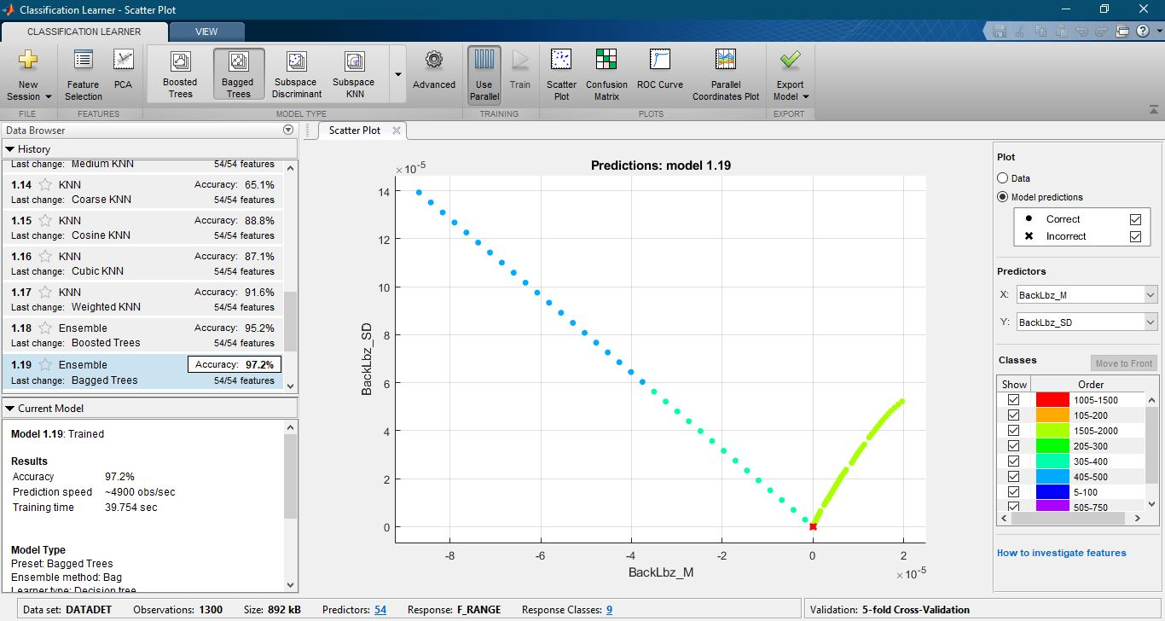
Figure 7. Classifier User-Interface

The classification learner first plots the scatter plots of all samples with respect to two selected features. It is only possible to visualize the data with two dimensions whereas having 54 features distributes the data in 54 dimensions which is very have to visualize or even imagine. In the figures bellow, the data samples are plotted for the sensor BackLbz with all three features with respect to each other.
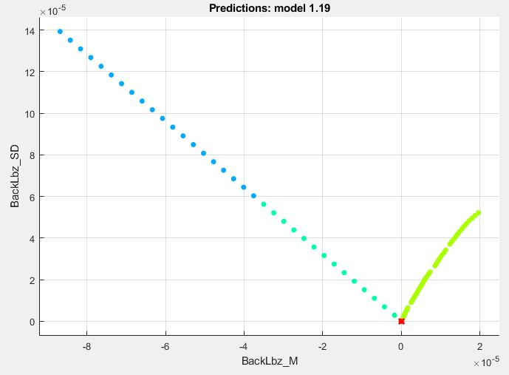
Figure 8. Scatterplot of the Mean with respect to the Standard Deviation

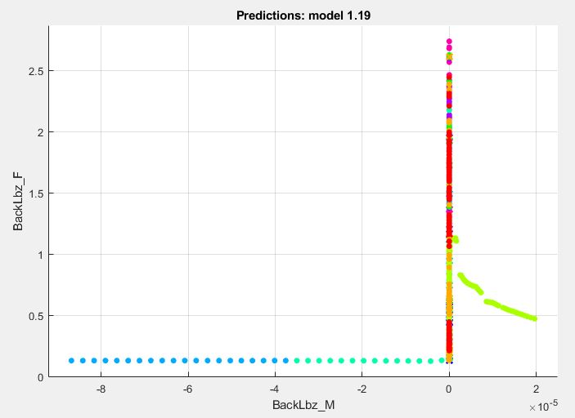
Figure 9. Scatterplot of the Mean with respect to the Mean Frequency

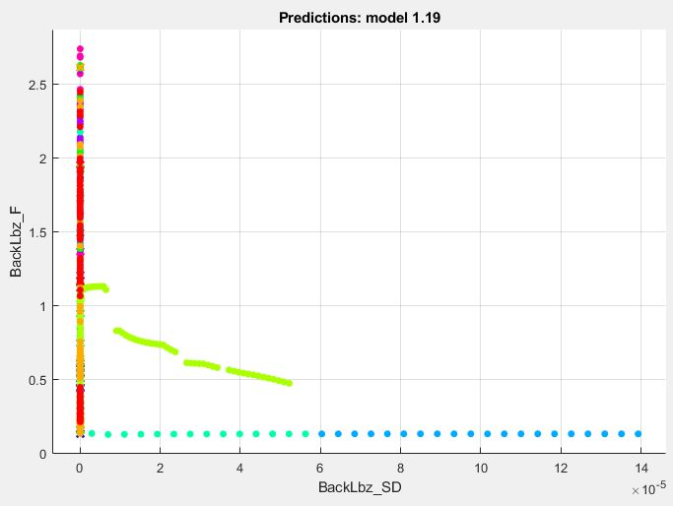
Figure 10. Scatterplot of the Standard Deviation with respect to the Mean Frequency

As the data samples are now distributed and scattered, the best classification algorithm can be deduced. But in this case, due to the high number of dimensions, 21 algorithms are used and the algorithm with the highest accuracy is the one to be considered. Taking the algorithm with the highest accuracy into consideration is adopting the algorithm with the lowest error. The results of the classification for the force range and location using all algorithms are summarized in the table below.

Table 1. Classification Algorithm Results Comparison
Algorithm | Accuracy (Force Magnitude Classification) | Accuracy (Force Location Classification)
Fine Tree | 95.8% | 97.2%
Medium Tree | 83.8% | 96.7%
Coarse Tree | 55.2% | 73.8%
Linear Discriminant | 92.2% | 92.6%
Quadratic Discriminant | Failed | 94.7%
Linear SVM | 90.8% | 88.8%
Quadratic SVM | 94.6% | 95.5%
Cubic SVM | 94.2% | 96.6%
Fine Gaussian SVM | 93.3% | 93.2%
Medium Gaussian SVM | 91.9% | 90.4%
Coarse Gaussian SVM | 74.6% | 78.2%
Fine KNN | 92.8% | 93.8%
Medium KNN | 89.9% | 90.8%
Coarse KNN | 65.4% | 73.3%
Cubic KNN | 90.0% | 90.8%
Weighted KNN | 87.8% | 89.6%
Boosted KNN | 92.1% | 92.6%
Ensemble Boosted Trees | 95.2% | 98.2%
Ensemble Bagged Trees | 97.3% | 98.8%
Ensemble Subspace Discriminant | 77.2% | 88.1%
Ensemble Subspace KNN | 90.3% | 92.2%
Ensemble RUSBoosted Trees | 91.5% | 97.5%

The best model to classify the data collected is the Ensemble Bagged Trees model which performed with a 97.3% accuracy to classify the force magnitude range and a 98.8% accuracy to classify the force location. We can deduce that this algorithm converges to solutions with 2.7% error for the force magnitude classification and 2.2% for the force location classification.
Many other models converged with a remarkably good accuracy for both classification problems. It is noticeable that the algorithms with the decision tree structure best classy the data. All results can be clearly analyzed in a confusion matrix. The results of the Ensemble Bagged Trees algorithm are shown in the figures below. The confusion matrices declare the number of times the model made a good guess or a false guess for each response. It can be deduced from the confusion matrix with the percentages that when the range of the forces is larger and at the positions that can take a higher force magnitude limit, the accuracy increases and the probability that the model will make mistakes decreases due to the increased number of trained samples.
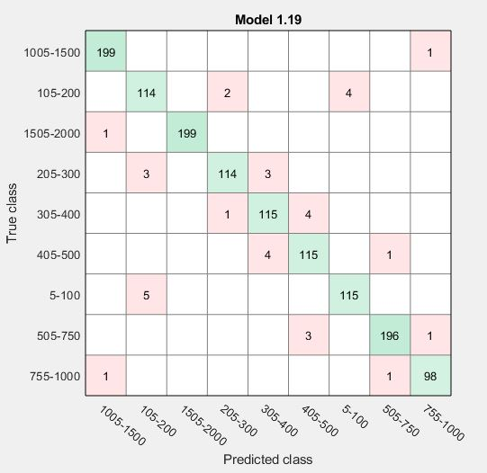
Figure 11. Force Magnitude Range Classification Confusion Matrix

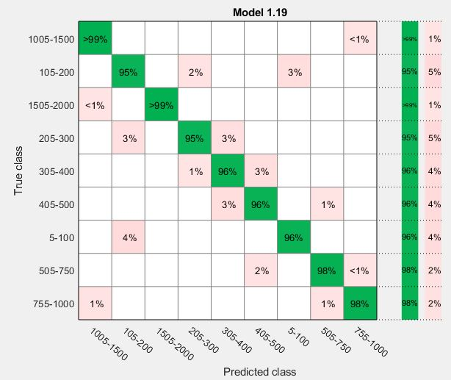
Figure 12.Force Magnitude Range Classification Confusion Matrix

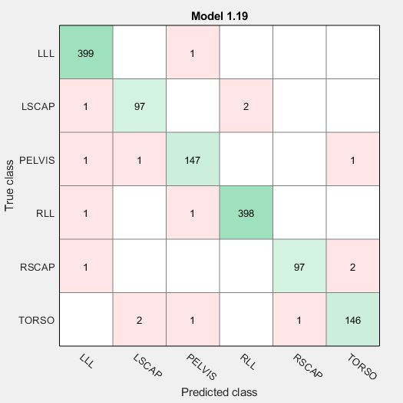
Figure 13.Force Location Classification Confusion Matrix

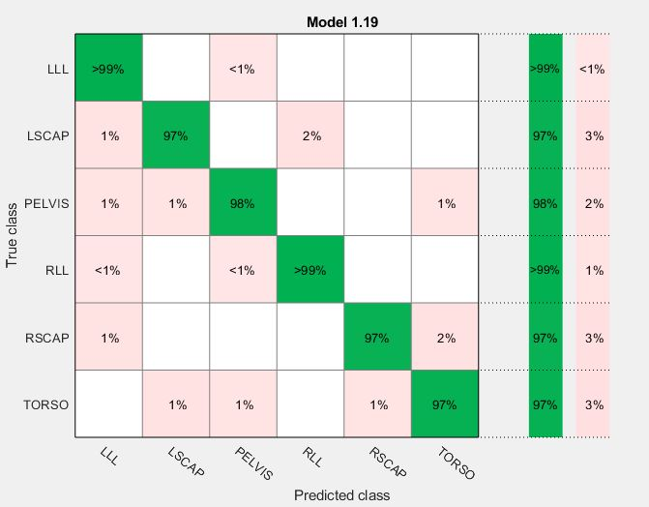
Figure 14. Force Magnitude Range Classification Confusion Matrix

